Dear Member,

Thank you for including Central Sunbelt Federal Credit Union in your auto loan plans.

- Car shopping now?. Can you use a $50 Visa gift card or a free $20 gas card? We would like to make your next vehicle purchase easy and put some extra money in your pocket. Click on the AutoCash NOW button below, watch the short video, then download and print your certificate before you shop for your next car - you’ll be glad you did!
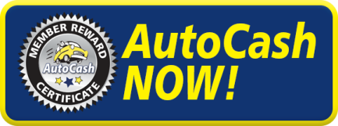

- Car shopping in the future? Not ready for a new ride? No worries, just click the AutoCash Later button below and tell us your estimated future vehicle purchase date and we’ll re-send this offer at that time!
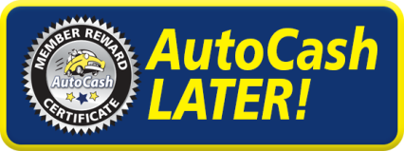

We hope you enjoy the AutoCash Reward promotion… and your next Central Sunbelt FCU loan.

Thanks again for your membership!

